**CHƯƠNG 1: SỬ DỤNG GMAIL**

**1.Tạo nhóm liên hệ**

Gửi mail tới nhóm thành viên

**2. Tạo bộ lọc**



Lọc từ khóa

CHƯƠNG 2: DÙNG MẠNG XÃ HỘI

Facebook: <https://www.facebook.com/share/g/16iYd99GvM/>



Link Zalo: <https://zalo.me/g/ltcppa854>



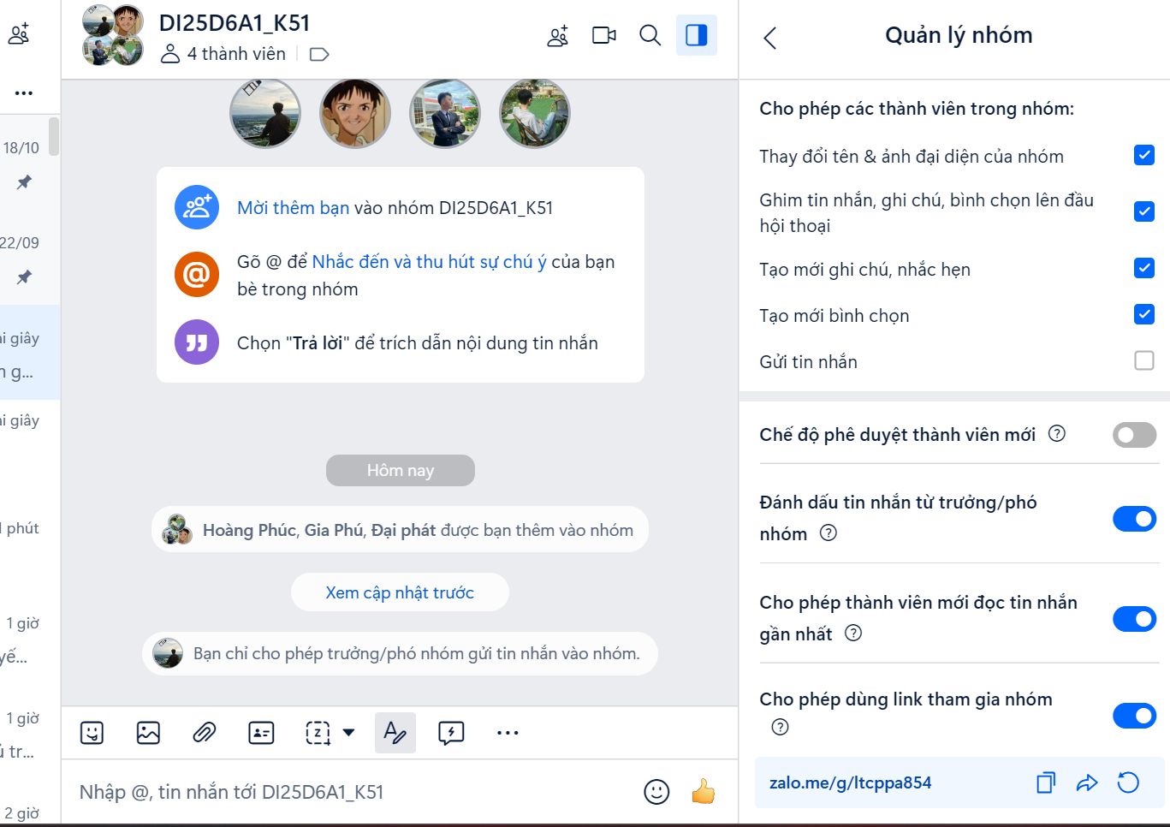

CHƯƠNG 3 GOOGLE MEET

